ASSET MANAGEMENT PORTAL
- Introduction
An Asset Management Portal is a centralized digital platform designed to efficiently track, manage, and monitor an organization’s physical and digital assets throughout their lifecycle. Assets may include hardware equipment, software licenses, infrastructure resources, and other valuable organizational properties. The primary objective of an asset management portal is to improve asset utilization, reduce operational costs, and ensure transparency and accountability.
In modern organizations, manual asset tracking methods are time-consuming, error-prone, and inefficient. An Asset Management Portal automates asset registration, allocation, maintenance scheduling, and disposal processes, thereby minimizing human errors and improving operational efficiency. It provides real-time visibility into asset status, location, ownership, and usage history.
Additionally, the portal supports decision-making by generating detailed reports and analytics related to asset performance, depreciation, and maintenance costs. With role-based access control and secure data handling, the system ensures data integrity and confidentiality. Overall, an Asset Management Portal plays a crucial role in enhancing organizational productivity, optimizing resource management, and supporting long-term strategic planning.

Team ID : LTVIP2026TMIDS66363
Team Leader : Kanadam Sai Sowmya
Team member : Pasupula Likhitha
Team member : Punnati Tarun Kumarreddy
Team member : Shaik Mushra

2. Project Overview
• Purpose: Briefly describe the purpose and goals of the project. • Features: Highlight key features and functionalities.
3. Architecture
• Frontend: Describe the frontend architecture using React.
• Backend: Outline the backend architecture using Node.js and Express.js. • Database: Detail the database schema and interactions with MongoDB.
4. Setup Instructions
• Prerequisites: List software dependencies (e.g., Node.js, MongoDB). • Installation: Step-by-step guide to clone, install dependencies, and set up the environment variables.
5. Folder Structure
• Client: Describe the structure of the React frontend.
• Server: Explain the organization of the Node.js backend.
6. Running the Application
• Provide commands to start the frontend and backend servers locally. o Frontend: npm start in the client directory.
o Backend: npm start in the server directory.
7. API Documentation
• Document all endpoints exposed by the backend.
• Include request methods, parameters, and example responses. 8. Authentication
• Explain how authentication and authorization are handled in the project. • Include details about tokens, sessions, or any other methods used.
9. User Interface
• Provide screenshots or GIFs showcasing different UI features.
10. Testing
• Describe the testing strategy and tools used.
11. Screenshots or Demo
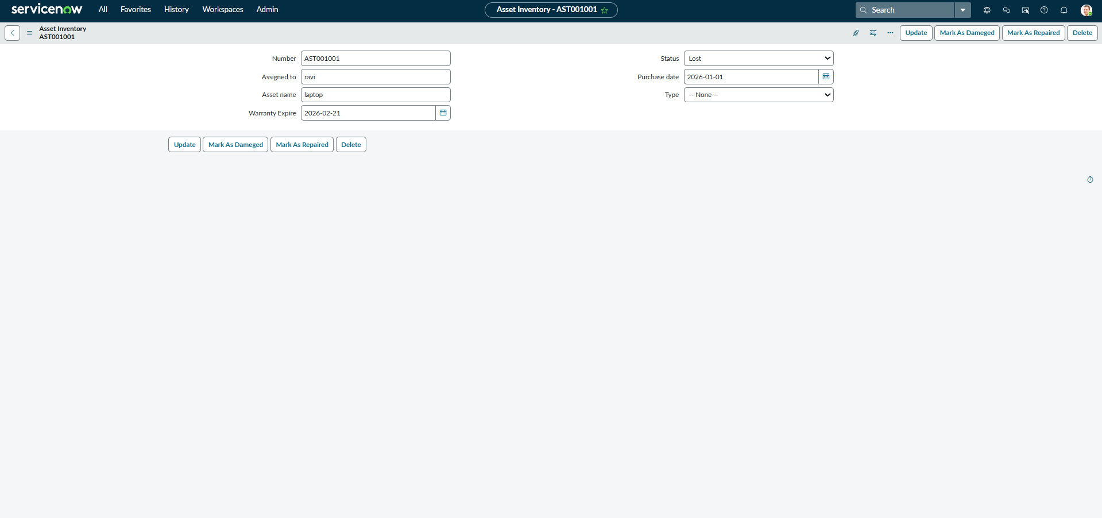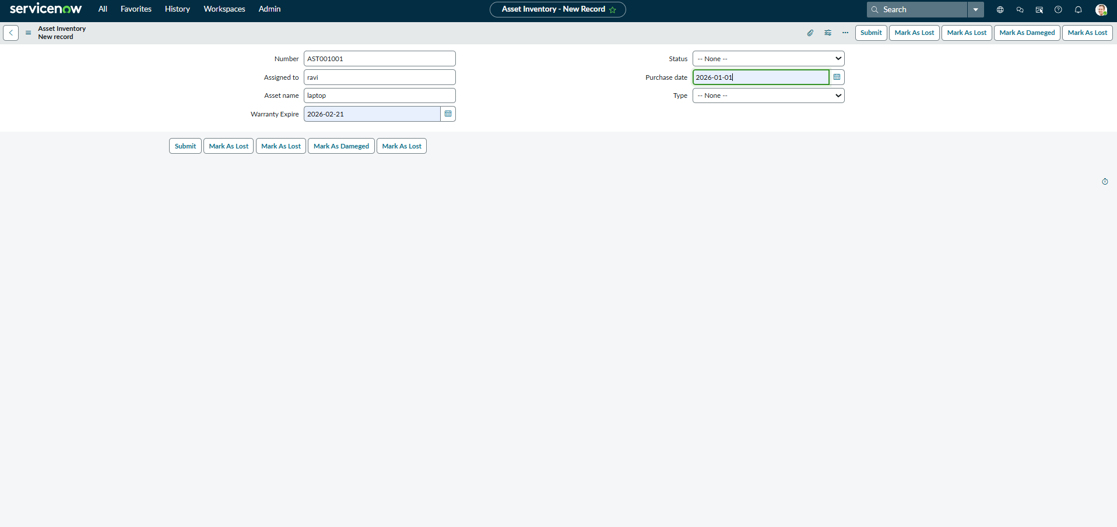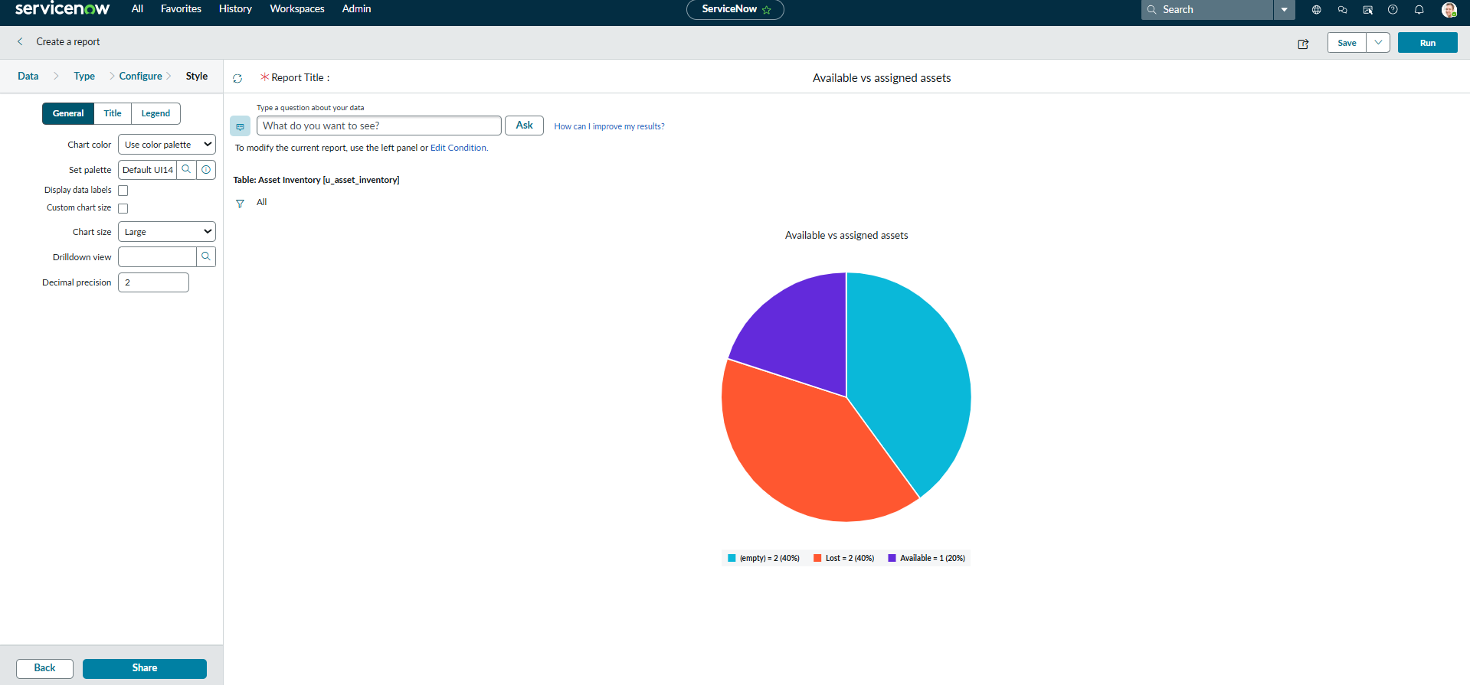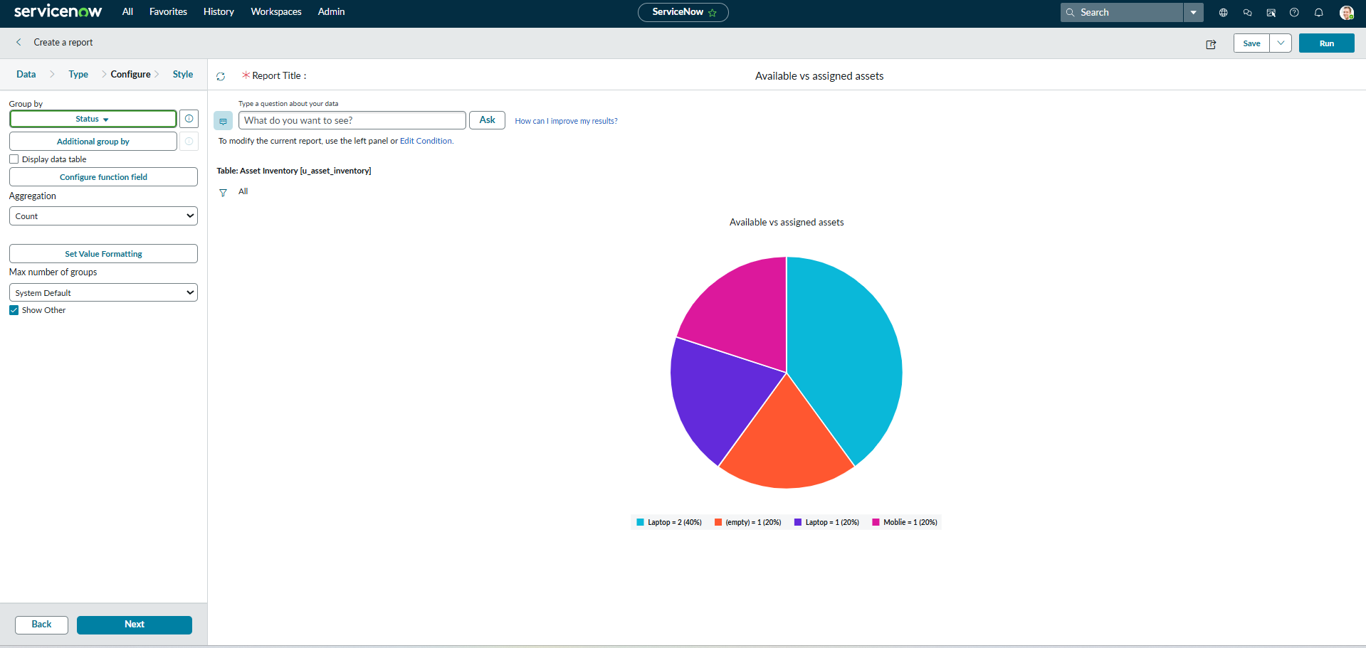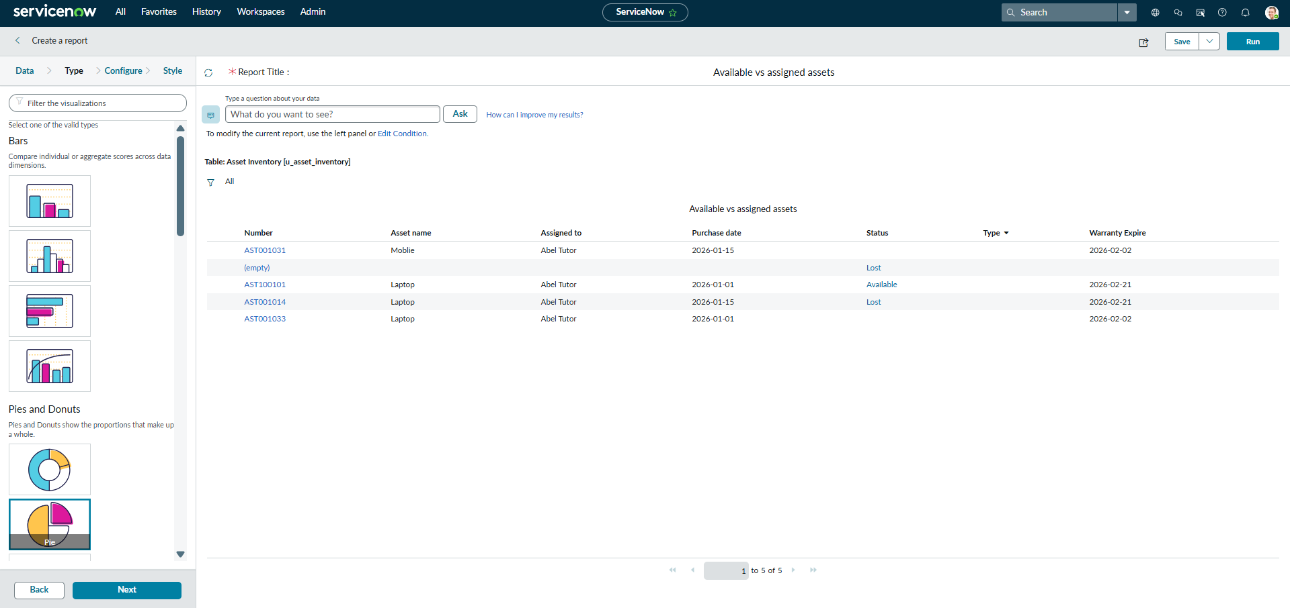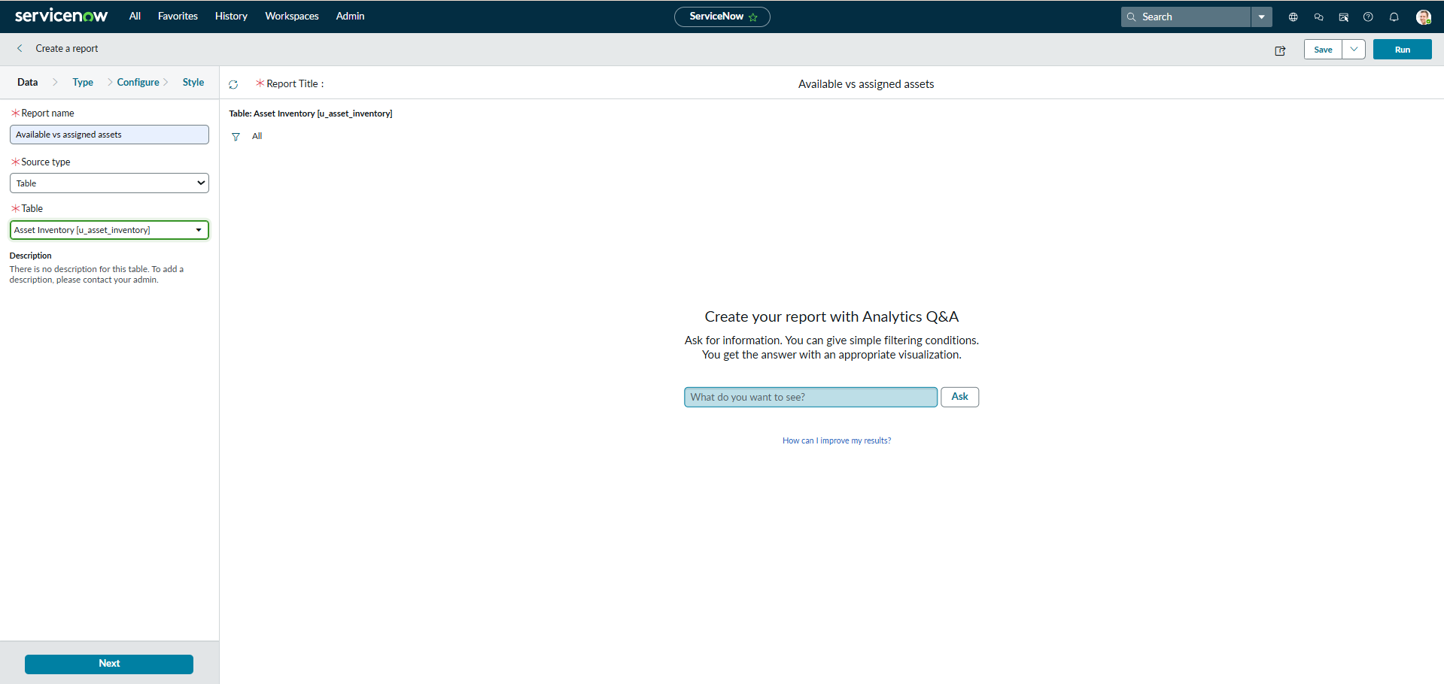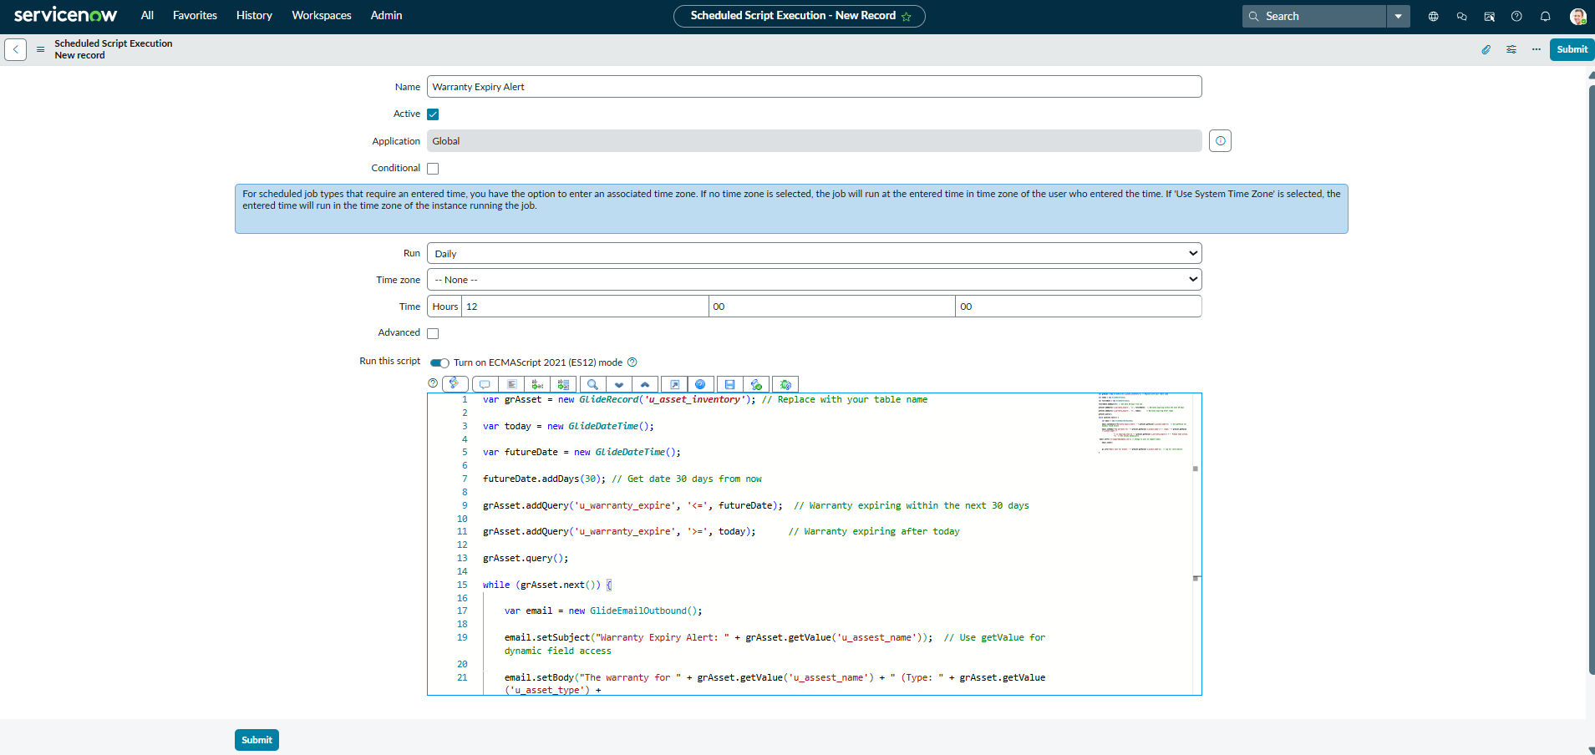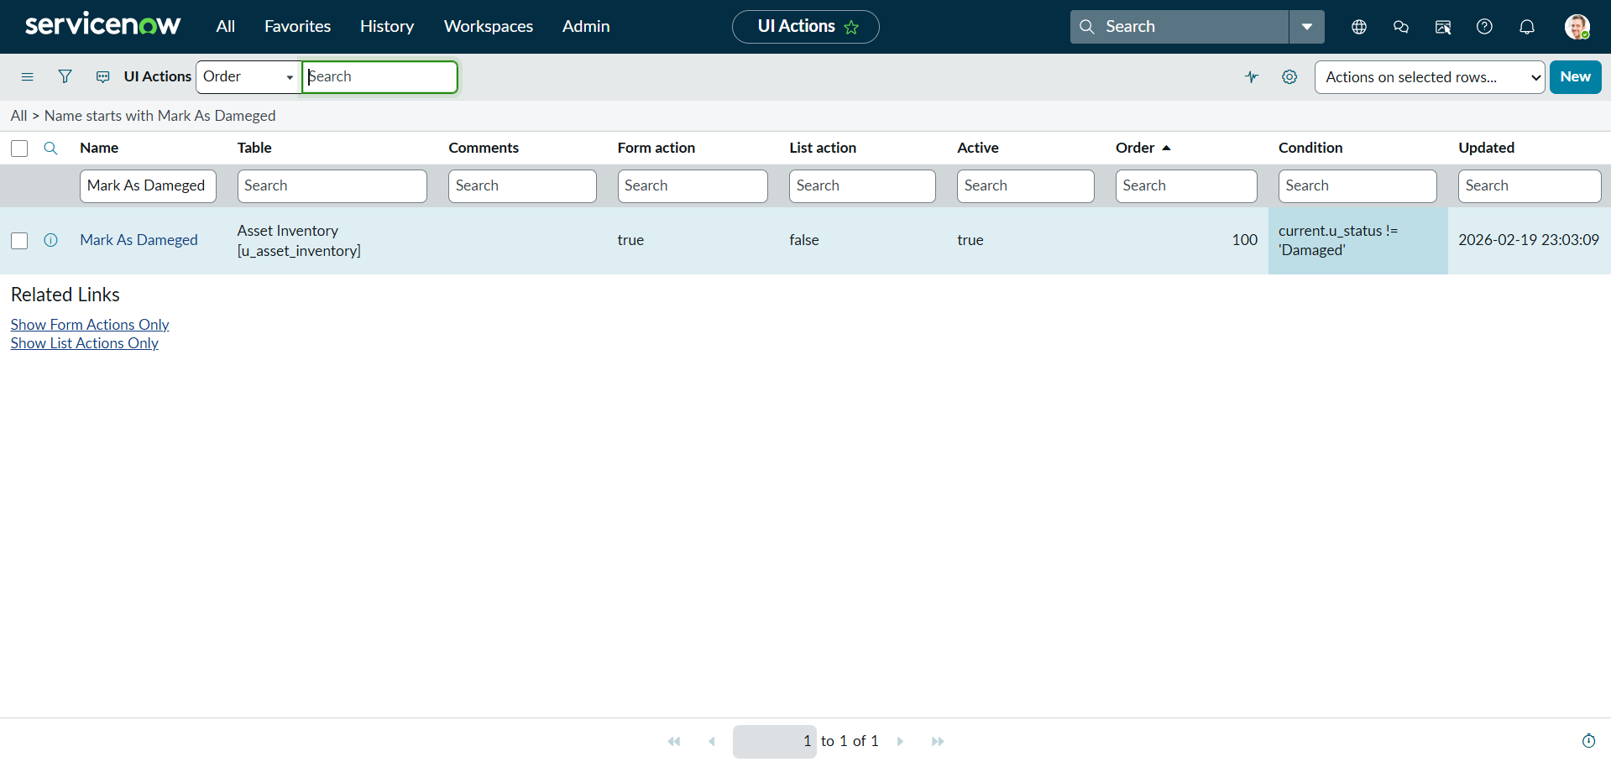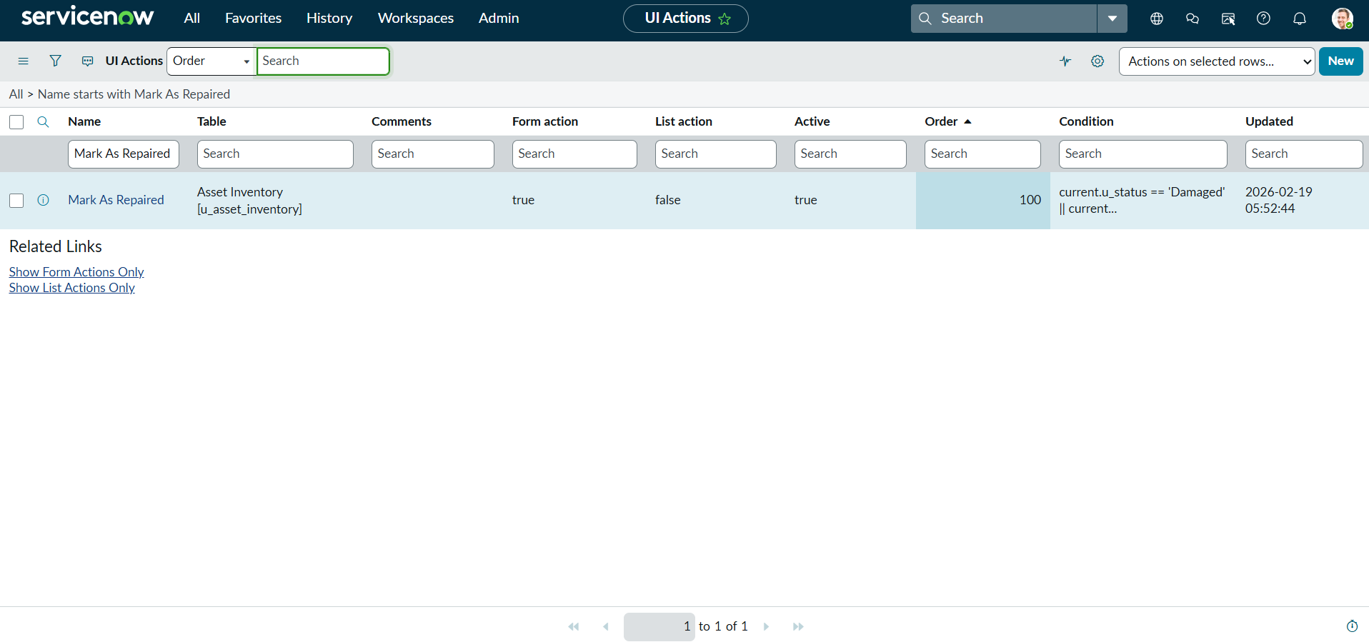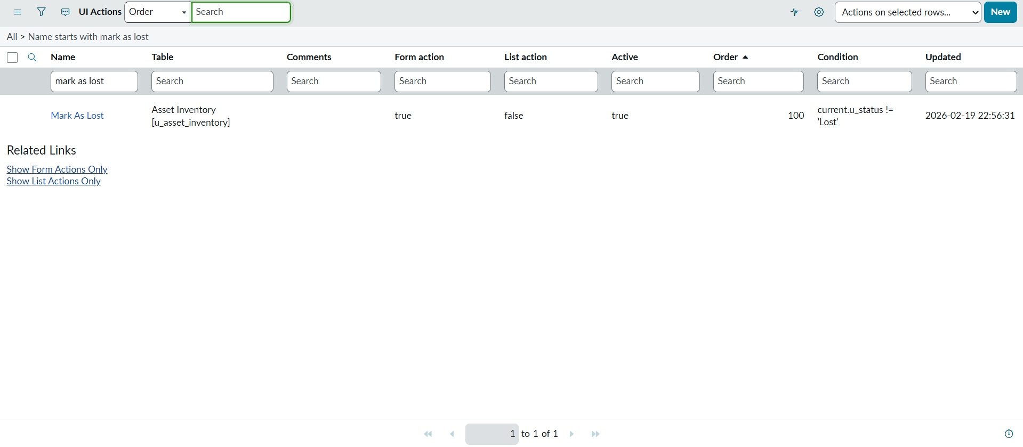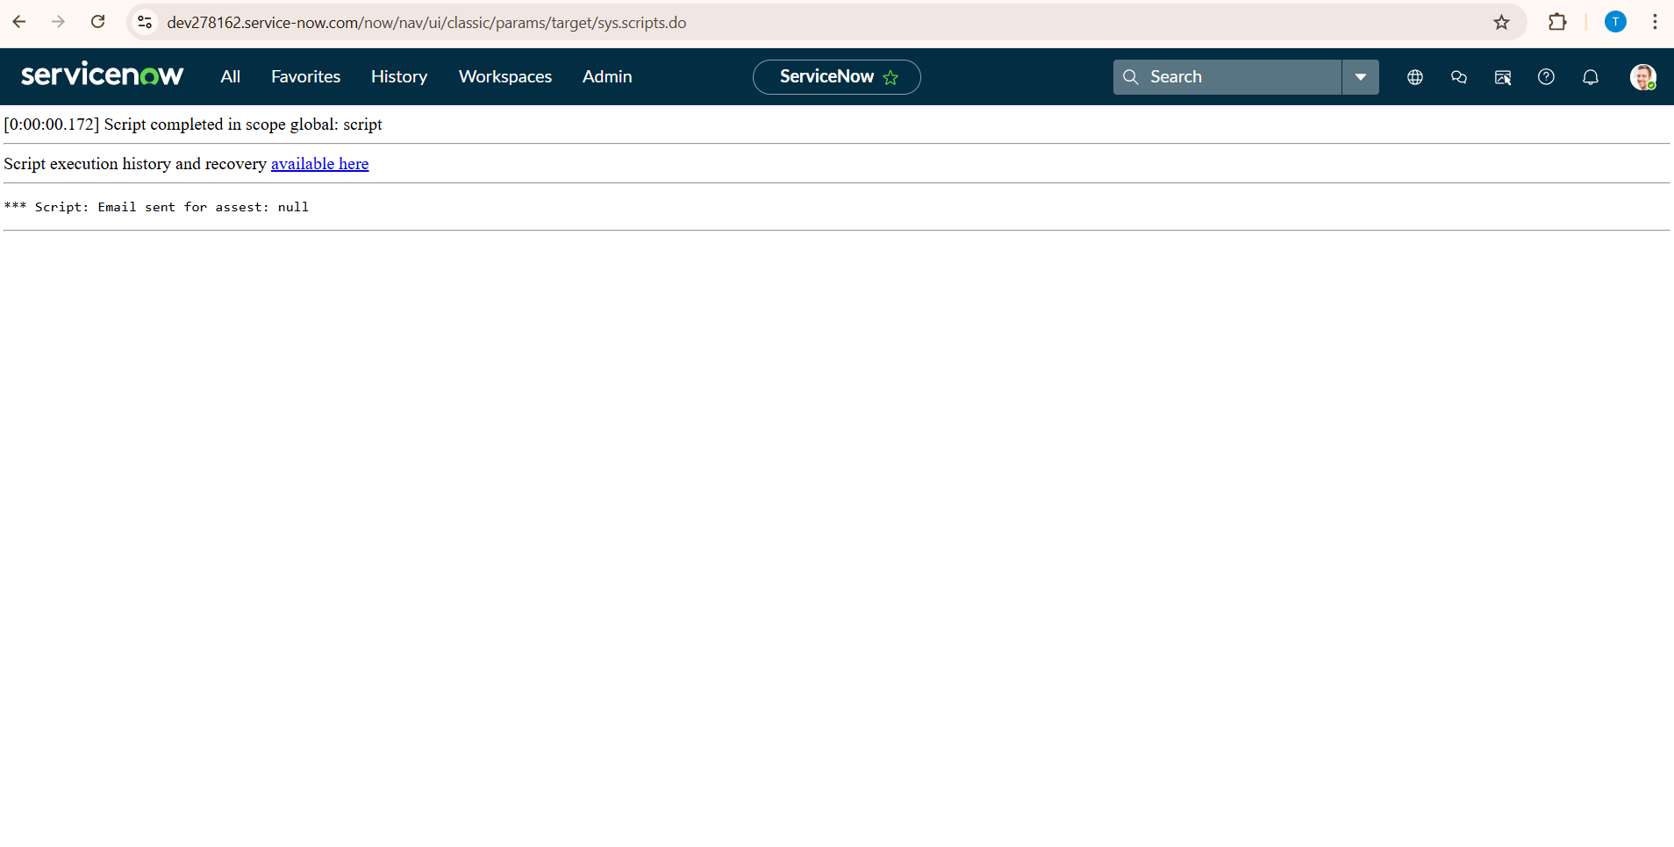
12. Known Issues

• Document any known bugs or issues that users or developers should be aware of. 13. Future Enhancements
• Outline potential future features or improvements that could be made to the project.

